Name: Muhammad Shakir khan

Reg No: Fa20-Bse-133

Mid Term Lab:

**Class Diagram:**

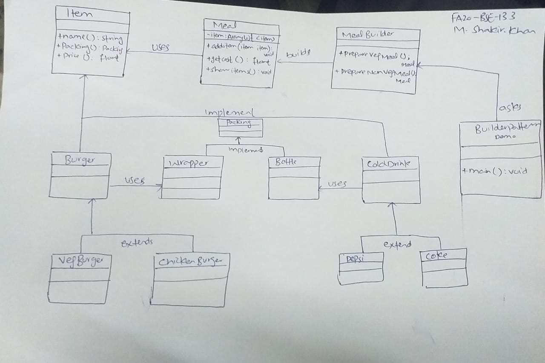

Implementation Code:

Builderpattern Demo:

/*

* To change this license header, choose License Headers in Project Properties.

* To change this template file, choose Tools | Templates

* and open the template in the editor.

*/

package main;

/**

*

* @author fa20-bse-133

*/

public class BuilderPatternDemo {

public static void main(String[] args) {

MealBuilder mealBuilder = new MealBuilder();

Meal vegMeal = mealBuilder.prepareVegMeal();

System.out.println("Veg Meal");

vegMeal.showItems();

System.out.println("Total Cost: " + vegMeal.getCost());

Meal nonVegMeal = mealBuilder.prepareNonVegMeal();

System.out.println("\n\nNon-Veg Meal");

nonVegMeal.showItems();

System.out.println("Total Cost: " + nonVegMeal.getCost());

}

}

Meal Builder:

/*

* To change this license header, choose License Headers in Project Properties.

* To change this template file, choose Tools | Templates

* and open the template in the editor.

*/

package main;

/**

*

* @author fa20-bse-133

*/

public class MealBuilder {

public Meal prepareVegMeal (){

Meal meal = new Meal();

meal.addItem(new VegBurger());

meal.addItem(new Coke());

return meal;

}

public Meal prepareNonVegMeal (){

Meal meal = new Meal();

meal.addItem(new ChickenBurger());

meal.addItem(new Pepsi());

return meal;

}

}

Meal:

/*

* To change this license header, choose License Headers in Project Properties.

* To change this template file, choose Tools | Templates

* and open the template in the editor.

*/

package main;

/**

*

* @author fa20-bse-133

*/

import java.util.ArrayList;

import java.util.List;

public class Meal {

private List<Item> items = new ArrayList<Item>();

public void addItem(Item item){

items.add(item);

}

public float getCost(){

float cost = 0.0f;

for (Item item : items) {

cost += item.price();

}

return cost;

}

public void showItems(){

for (Item item : items) {

System.out.print("Item : " + item.name());

System.out.print(", Packing : " + item.packing().pack());

System.out.println(", Price : " + item.price());

}

}

}

Pepsi:

/*

* To change this license header, choose License Headers in Project Properties.

* To change this template file, choose Tools | Templates

* and open the template in the editor.

*/

package main;

/**

*

* @author fa20-bse-133

*/

public class Pepsi extends ColdDrink {

@Override

public float price() {

return 35.0f;

}

@Override

public String name() {

return "Pepsi";

}

**}**

**Coke Class:**

/*

* To change this license header, choose License Headers in Project Properties.

* To change this template file, choose Tools | Templates

* and open the template in the editor.

*/

package main;

/**

*

* @author fa20-bse-133

*/

public class Coke extends ColdDrink {

@Override

public float price() {

return 30.0f;

}

@Override

public String name() {

return "Coke";

}

}Chicken Burgur Class:

/*

* To change this license header, choose License Headers in Project Properties.

* To change this template file, choose Tools | Templates

* and open the template in the editor.

*/

package main;

/**

*

* @author fa20-bse-133

*/

public class ChickenBurger extends Burger {

@Override

public float price() {

return 50.5f;

}

@Override

public String name() {

return "Chicken Burger";

}

}

**VegBurger:**

/*

* To change this license header, choose License Headers in Project Properties.

* To change this template file, choose Tools | Templates

* and open the template in the editor.

*/

package main;

/**

*

* @author fa20-bse-133

*/

public class VegBurger extends Burger {

@Override

public float price() {

return 25.0f;

}

@Override

public String name() {

return "Veg Burger";

}

}

**ColdDrink:**

/*

* To change this license header, choose License Headers in Project Properties.

* To change this template file, choose Tools | Templates

* and open the template in the editor.

*/

package main;

/**

*

* @author fa20-bse-133

*/

public abstract class ColdDrink implements Item {

@Override

public Packing packing() {

return new Bottle();

}

@Override

public abstract float price();

}

**Burger Class:**

/*

* To change this license header, choose License Headers in Project Properties.

* To change this template file, choose Tools | Templates

* and open the template in the editor.

*/

package main;

/**

*

* @author fa20-bse-133

*/

public abstract class Burger implements Item {

@Override

public Packing packing() {

return new Wrapper();

}

@Override

public abstract float price();

}

**Bottle lass:**

/*

* To change this license header, choose License Headers in Project Properties.

* To change this template file, choose Tools | Templates

* and open the template in the editor.

*/

package main;

/**

*

* @author fa20-bse-133

*/

public class Bottle implements Packing {

@Override

public String pack() {

return "Bottle";

}

}

**Wrapper Class:**

/*

* To change this license header, choose License Headers in Project Properties.

* To change this template file, choose Tools | Templates

* and open the template in the editor.

*/

package main;

/**

*

* @author fa20-bse-133

*/

public class Wrapper implements Packing {

@Override

public String pack() {

return "Wrapper";

}

}

**Packing Class:**

/*

* To change this license header, choose License Headers in Project Properties.

* To change this template file, choose Tools | Templates

* and open the template in the editor.

*/

package main;

/**

*

* @author fa20-bse-133

*/

public interface Packing {

public String pack();

}

**Item Class:**

/*

* To change this license header, choose License Headers in Project Properties.

* To change this template file, choose Tools | Templates

* and open the template in the editor.

*/

package main;

/**

*

* @author fa20-bse-133

*/

public interface Item {

public String name();

public Packing packing();

public float price();

}

**Main Class:**

/*

* To change this license header, choose License Headers in Project Properties.

* To change this template file, choose Tools | Templates

* and open the template in the editor.

*/

package main;

/**

*

* @author fa20-bse-133

*/

public class Main {

/**

* @param args the command line arguments

*/

public static void main(String[] args) {

// TODO code application logic here

}

}